



Medicaid and Human Services Transparency and Fraud Prevention Act
Bi-Annual Status Report

January 1, 2023
State of Mississippi
Division of Medicaid
Department of Human Services

Table of Contents
1 Legislative Request 4
2 Executive Summary 5
3 Background 7
4 Current House Bill 1090 Status 8
4.1 Short title 8
4.2 Integration of eligibility systems 8
4.3 Real-time eligibility verification service 8
4.4 Enhanced eligibility verification process 11
4.5 Enhanced identity authentication process 11
4.6 Discrepancies and case review 12
4.7 Referrals for fraud, misrepresentation, or inadequate documentation 12
4.8 Reporting 12
4.9 Transparency in Medicaid 12
4.10 Work requirements 13
4.11 Federal asset limits for the Supplemental Nutrition Assistance Program 13
4.12 Broad-based categorical eligibility 13
4.13 Sharing enrollee information across agencies 14
4.14 Maximum family grant 14
4.15 Verify identities and household composition, and all expenses of welfare applicants 15
4.16 Full cooperation with fraud investigations 15
4.17 Gaps in eligibility reporting 15
4.18 Noncompliance with Temporary Assistance for Needy Families program rules 16
4.19 Noncompliance with Supplemental Nutrition Assistance Program rules 17
4.20 Out-of-state spending 17
4.21 Public reporting 17
4.22 Pilot program for photos on EBT cards 17
4.23 Limits on spending location 18
4.24 Excessive EBT card loss 18
4.25 Timeframes 19
5 Appendix A: House Bill 1090 – Section 20: Out of State Spending 20
6 Appendix B: House Bill 1090 – Section 21: Public Reporting 28
6.1 Report Design 28
6.1.1 Average Length of Enrollment 28
6.1.2 Recipients Enrolled in One or More Programs 29
6.1.3 Demographics and Characteristics of Recipients 30
6.1.4 Amount Spent on Advertising Means-Tested Programs 33

Legislative Request
This report is in response to the legislative requirement in the Medicaid and Human Services Transparency and Fraud Prevention Act (House Bill 1090). Section 3 requires:
“The department shall have the eligibility verification service required by this section implemented and operational not later than July 1, 2019. The department shall submit a report every six (6) months on its progress on implementing the eligibility verification service to the Chairmen of the House and Senate Appropriations Committees, the House Public Health and Human Services Committee and the Senate Public Health and Welfare Committee, and the House and Senate Medicaid Committees. The report also shall be provided to the other members of the Legislature upon request.”
This report was prepared by the Mississippi Division of Medicaid (DOM) and Mississippi Department of Human Services (MDHS).

Executive Summary
DOM and MDHS are pleased to submit this Bi-Annual Status Report on the progress on the Medicaid and Human Services Transparency and Fraud Prevention Act (House Bill 1090).
DOM and MDHS jointly launched the Health and Human Services Transformation Project or “HHSTP” in July 2017 to accomplish the goals of House Bill 1090 by the deadlines specified in Section 25. DOM and MDHS submitted the first required report on July 11, 2017. That report focused on satisfying all provisions of Section 2 and securing federal approvals and funding. This Bi-Annual Status Report will provide a status on all sections of House Bill 1090.
DOM and MDHS have completed/implemented or cannot implement based on federal regulations approximately 76% of the applicable twenty-three provisions of House Bill 1090 and are currently working to implement the remainder of the provisions. Table 1 below provides an overview of the status of these provisions with further detail provided in the corresponding narrative in Section 4.
Table 1: House Bill 1090 Summary of Provision Status
Section # | Section Title | Status
1 | Short Title | Acknowledged
2 | Integration of eligibility systems | Complete
3 | Real-time eligibility verification service | In-progress
4 | Enhanced eligibility verification process | In-progress
5 | Enhanced identity authentication process | In-progress/ Partially prohibited by Federal Regulations
6 | Discrepancies and case review | In-progress
7 | Referrals for fraud, misrepresentation, or inadequate documentation | Complete
8 | Reporting | In-progress
9 | Transparency in Medicaid | Complete
10 | Work Requirements | Complete
11 | Federal asset limits for the Supplemental Nutrition Assistance Program | Complete
12 | Broad-based categorical eligibility | Complete
13 | Sharing enrollee information across agencies | In-progress
14 | Maximum family grant | Complete
15 | Verify identities and household composition, and all expenses of welfare applicants | Complete
16 | Full cooperation with fraud investigations | Prohibited by Federal Regulations
17 | Gaps in eligibility reporting | Complete
18 | Noncompliance with Temporary Assistance for Needy Families program rules | Complete
19 | Noncompliance with Supplemental Nutrition Assistance Program rules | Complete
20 | Out-of-state spending | SNAP Provided/TANF Prohibited by Federal Regulations
21 | Public Reporting | Complete
22 | Pilot program for photos on EBT cards | Determined not to be feasible/ Significant negative cost-benefit ratio
23 | Limits on spending location | Complete
24 | Excessive EBT card loss | Complete
25 | Timeframes | Acknowledged

Background
As required by House Bill 1090, DOM and MDHS delivered an initial report on July 11, 2017 on Section 2 and the progress toward submitting an Advanced Planning Document (APD). Building on work already in progress between the two agencies prior to the enactment of House Bill 1090 (Hope Act), DOM and MDHS signed a Memorandum of Understanding (MOU) to develop a vision of interoperability and shared services leveraging 90/10 Federal Financial Participation (FFP) and A-87 Cost Allocation Exception. DOM and MDHS finalized a joint vision in January 2017, drafted the APD in parallel to the 2017 Legislative Session, and submitted it shortly after the passage of the HOPE Act in April 2017. This approach enabled DOM and MDHS to act on the legislation quickly while giving the State the maximum time available to leverage the A-87 Exception, which expired at the end of 2018. DOM and MDHS reported in the July 11, 2017 initial report that our Federal partners, the Centers for Medicare & Medicaid Services (CMS) and the Food and Nutrition Services (FNS) have approved the APD. The approved APD allowed DOM and MDHS to receive FFP for approximately $46M in IT investments with a State share of approximately $8M or 17%.
DOM and MDHS jointly launched the HHSTP in July 2017 which is dedicated to accomplishing the goals of House Bill 1090 and the APD. As of this report, DOM and MDHS have launched the Common Web Portal (CWP) which has processed 575,000+ applications for enrollment while strengthening program integrity through meeting 76% of the provisions of House Bill 1090. We anticipate House Bill 1090’s remaining elements will be satisfied through the Fraud and Abuse Module (FAM). The status of that module is detailed in this document in Section 4.3.

Current House Bill 1090 Status
As of January 2023, the current status for each of the Sections of the Medicaid and Human Services Transparency and Fraud Prevention Act is provided below. The Subsections that follow within this report follow the Sections as written in the bill, and all references beyond this point shall constitute references to Sections within the Medicaid and Human Services Transparency and Fraud Prevention Act, unless otherwise noted.

Short title
Status: Acknowledged
DOM and MDHS acknowledge the act shall be known as the "Medicaid and Human Services Transparency and Fraud Prevention Act."

Integration of eligibility systems
Status: Complete
DOM and MDHS submitted an Initial Advanced Planning Document to CMS and FNS on April 3, 2017 and a final report was submitted to the legislature on July 11, 2017. All requests made in the Medicaid and Human Services Transparency and Fraud Prevention Act, Section 2 were included as part of the final Advanced Planning Document. Section 2 of the Medicaid and Human Services Transparency and Fraud Prevention Act has been completed.

Real-time eligibility verification service
Status: In-progress
DOM and MDHS have completed capturing detailed requirements for developing a computerized income, asset, residence and identity eligibility verification service. This service will verify eligibility, eliminate the duplication of assistance, and deter waste, fraud, and abuse within each respective assistance program. DOM and MDHS have carefully defined the aspects of the service, analyzing existing processes, and conducting analysis to maximize value to the State and minimize costs. DOM and MDHS worked to create an RFP for the acquisition of a vendor to assist with the creation of the real-time eligibility verification service and achieve approval from CMS and FNS using the Medicaid and Human Services Transparency and Fraud Prevention Act and CMS and FNS requirements as guiding documents. Softheon Inc. was selected as the vendor to provide FAM services. Work began in May 2020 to customize and implement this real-time eligibility verification service. The initial implementation including availability for asset verification services for DOM started in early June 2022, and full functionality for both agencies is planned for Fall 2023. Antiquated MDHS data systems hindered progress in implementing real-time data management. Section 3 of the Medicaid and Human Services Transparency and Fraud Prevention Act is in-progress.
The agencies acknowledge that real-time eligibility service is not currently implemented, yet believe it relevant to share what data is already being validated or verified. Figure 1 below illustrates which of the requested verifications are already occurring while the agencies work to prepare for the implementation of the FAM, and how often those verifications are reported.
Figure 1: Data Currently Verified
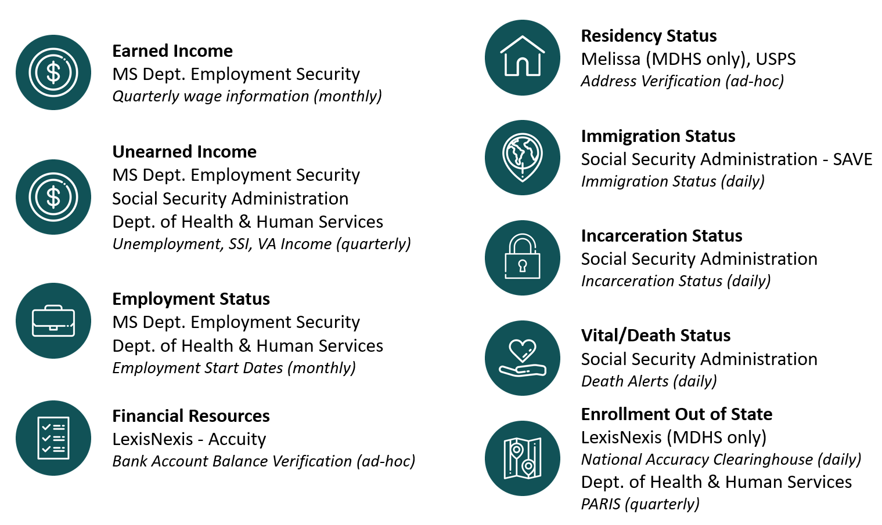
All interfaces are offered at no cost, or are already part of other program budgets, with the exception of LexisNexis - Accuity products.
In January 2019, DOM began utilizing a manual process for asset verification for full coverage Aged, Blind, Disabled (ABD) cases during the yearly renewal process. Due to the Covid-19 pandemic and consequent CMS guidelines, no renewals were conducted from April 2020 to the present. Based on CMS requirements, the State cannot drop coverage on current members until the public health emergency is over. However, the asset verification is used for new applications and from December 1, 2021 until June 30, 2022, there were 4 ABD applications denied due to asset verification checks. Additionally, in the timespan from July 1, 2022 until November 30, 2022, there were 2 ABD applications denied due to asset verification checks. According to the Kaiser Institute, the annual per person cost for Medicaid in Mississippi is approximately $11,000 per year if the beneficiary is aged or disabled. Utilizing this estimate, DOM calculates a cost avoidance of $22,000 total during these time periods.
MDHS implemented a manual asset verification process for SNAP and TANF applications beginning July 1, 2019. There were approximately 6,895 applications processed and selected for the asset verification review during the period of December 1, 2021 to November 30, 2022. Of these cases, 2,476 cases were closed for various reasons, including changes in client income, moves out of state, and other factors. Based on the average monthly allotment for a one-person household, an estimated $619,000 in benefits per month would have been issued in closed cases. At this time, the agency is unable to determine the number of cases that were closed as a result of information generated during the asset verification process versus those closed for other reasons; therefore an estimated cost avoidance cannot be projected with confidence.
Additional improvements in business efficiencies may result from technological advancements leading to the planned transition from a manual process to an automated one with integration of the FAM and the eligibility system.
Available costs along with the actual and estimated cost avoidance associated with the asset verification products currently in use are identified in Figure 2.
Figure 2: Data Costs & Cost Avoidance For LexisNexis Products Currently in Use
Agency | Date Range | Cost | Cost Avoidance
DOM | 1/1/19 – 6/30/19 | $486,511.35 | $715,000.00
 | 7/1/19 – 11/30/19 | $177,669.00 | $275,000.00
 | 12/1/19 – 3/31/20 | No extra cost | $209,000.00
 | 4/1/19 – 11/30/20 | $147,250.00 | $671,000.00
 | 12/1/20 - 6/30/21 | No extra cost | $44,000.00 (Due to the public health emergency, redeterminations were not completed, but there were new applications denied due to liquid resources identified)
 | 7/1/21 – 11/30/21 | $279,179.09 | $55,000.00 (Due to the public health emergency, redeterminations were not completed, but there were 5 new applications denied due to liquid resources identified)
 | 12/1/21 – 6/30/22 | No extra cost | $44,000 (Due to the public health emergency, redeterminations were not completed, but there were 4 new applications denied due to liquid resources identified)
 | 7/1/22 – 11/30/22 | $275,183.00 | $22,000 (Due to the public health emergency, redeterminations were not completed, but there were 2 new applications denied due to liquid resources identified)
MDHS | *At this time, the agency is unable to determine the number of cases that were closed as a result of information generated during the asset verification process versus those closed for other reasons; therefore, an estimated cost avoidance cannot be projected with confidence.
 | Grand Totals | $1,365,792.44 | $2,035,000.00

Full implementation of the FAM will require substantial, ongoing expenditures of both state and federal funds by both agencies. In addition, the Social Security Administration has rejected requests from MDHS and DOM to use SSA data to identify and deter fraud (though SSA data is already consistently used in determining program eligibility), and our agencies are not allowed to share IRS data, preventing us from incorporating these tools into the FAM.

Enhanced eligibility verification process
Status: In-progress
DOM and MDHS acknowledge the request to verify eligibility for assistance by using the enhanced eligibility verification service established in Section 3(2) of the Medicaid and Human Services Transparency and Fraud Prevention Act as well as periodically reaffirming assets where applicable. DOM and MDHS already terminate recipients within active programs within a maximum of 10 days when the agency receives information about recipients moving out of state. The remaining items in this Section are dependent on the enhanced real-time eligibility verification service being completed. Updates to this Section will resume when Section 3 of the Medicaid and Human Services Transparency and Fraud Prevention Act is completed. Current progress can be found within Section 4.3 of this document.

Enhanced identity authentication process
Status: In-progress/Partially prohibited by Federal Regulations
DOM and MDHS acknowledge the request to verify identity of applicants before moving to the next stage in the eligibility process and before the possible awarding of assistance. Additionally, the departments acknowledge the request to review the recipient’s identity ownership periodically to verify and protect the identity of the recipient. DOM and MDHS have implemented phase 1 of the Common Web Portal and are working to complete the second and final phase of base functionality, including the identity authentication component that will allow for users of the CWP to authenticate their identity and have the opportunity to view programs they are enrolled in, as well as submit changes and manage their user account. The identity authentication functionality will be part of the final CWP implementation currently scheduled to be complete by mid-2023.
MDHS will continue to verify identity before awarding assistance. While MDHS will offer clients the opportunity to confirm their identity electronically, MDHS cannot require the client to do so. As, outlined in 7 CFR 273.3(f)(1)(vii)., “any documents which reasonably establish the applicant's identity must be accepted, and no requirement for a specific type of document, such as a birth certificate, may be imposed.” In addition, the CFR states that MDHS must accept verification of an individual’s identity through collateral contact if no documentary evidence is readily available.

Discrepancies and case review
Status: In-progress
DOM and MDHS are continuing to confirm that the requested processes and policies in this Section are implemented in their respective agencies. Both agencies use the best available information to process cases where discrepancies may exist. Once new information becomes known to the agencies, eligibility redeterminations are made. If discrepancies exist at that point, the agencies provide the client with written notification of the discrepancy and the recipient has 10 days to respond to resolve the discrepancy or change. The agencies view the enhanced verification service as an additional reliable data source and will use the data provided by it in future eligibility redeterminations. Until the combined DOM and MDHS enhanced verification service can be launched, DOM and MDHS have individually leveraged existing contracts to implement enhanced verifications that will be provided through the FAM when Section 3 of the Medicaid and Human Services Transparency and Fraud Prevention Act has been implemented. Details on data verifications already being utilized can be found in Figure 1, within Section 4.3. The remaining items in this Section are dependent on the enhanced real-time eligibility verification service being completed. Updates to this Section will resume when Section 3 of the Medicaid and Human Services Transparency and Fraud Prevention Act is completed. Current progress can be found within Section 4.3 of this document.

Referrals for fraud, misrepresentation, or inadequate documentation
Status: Complete
DOM and MDHS are continuing to confirm that the requested processes and policies in this Section are implemented in their respective agencies. Both agencies have implemented policy changes that require staff to refer changes or discrepancies that may affect program eligibility to appropriate agencies and divisions within 10 days. This includes suspected cases of fraud, misrepresentation, or inadequate documentation and cases where an individual is determined to be no longer eligible for the original program. In cases where fraud affecting program eligibility is substantiated, the agencies garnish wages and/or state income tax refunds until the state recovers an amount equal to the amount of benefits that were fraudulently received. Section 7 of the Medicaid and Human Services Transparency and Fraud Prevention Act has been implemented.

Reporting
Status: In-progress
DOM and MDHS acknowledge the request for a pre-development report as well as a post-implementation report referred to in Section 8 of the Medicaid and Human Services Transparency and Fraud Prevention Act. The pre-development report was delivered in excess of thirty (30) days before entering into a competitively bid contract with Softheon, Inc. The post-implementation report will be completed 6 months after the implementation of the enhanced eligibility verification service. The remaining post-implementation report will be delivered to the requested audiences when complete.

Transparency in Medicaid
Status: Complete
DOM has completed the request for the data specified in Section 9 of the Medicaid and Human Services Transparency and Fraud Prevention Act and has posted the following reports publicly on an external website. The reports can be found at the following address: https://medicaid.ms.gov/resources/legislative-resources/hope-act/
- Medicaid Physician and Other Supplier National Provider Identifier (NPI) Aggregate Report, Calendar Year 2021
- Medicaid National Healthcare Common Procedure Coding System (HCPCS) Aggregate Report Calendar Year 2021
- Medicaid Physician and Other Supplier National Provider Identifier (NPI) Aggregate Report, Calendar Year 2020
- Medicaid National Healthcare Common Procedure Coding System (HCPCS) Aggregate Report Calendar Year 2020
- Medicaid Physician and Other Supplier National Provider Identifier (NPI) Aggregate Report, Calendar Year 2019
- Medicaid National Healthcare Common Procedure Coding System (HCPCS) Aggregate Report Calendar Year 2019
- Medicaid Physician and Other Supplier National Provider Identifier (NPI) Aggregate Report, Calendar Year 2018
- Medicaid National Healthcare Common Procedure Coding System (HCPCS) Aggregate Report Calendar Year 2018
- Medicaid Physician and Other Supplier National Provider Identifier (NPI) Aggregate Report, Calendar Year 2017
- Medicaid National Healthcare Common Procedure Coding System (HCPCS) Aggregate Report Calendar Year 2017
- Medicaid Physician and Other Supplier National Provider Identifier (NPI) Aggregate Report, Calendar Year 2016
- Medicaid National Healthcare Common Procedure Coding System (HCPCS) Aggregate Report Calendar Year 2016

Work requirements
Status: Complete
As of January 2016, MDHS has not sought out, applied for, or accepted/renewed any waiver of requirements established under 7 USC Section 2015(o), except during a formal state or federal declaration of a natural disaster. Section 10 of the Medicaid and Human Services Transparency and Fraud Prevention Act has been implemented.

Federal asset limits for the Supplemental Nutrition Assistance Program
Status: Complete
MDHS has discontinued Broad-Based Categorical Eligibility and is reinforcing the current resource limits. For SNAP, the current resource limit is $2,250 for most households and $3,750 for households with at least one elderly and/or disabled household member. Section 11 of the Medicaid and Human Services Transparency and Fraud Prevention Act has been implemented.

Broad-based categorical eligibility
Status: Complete
Broad Based Categorical Eligibility has been discontinued; therefore, all households applying for SNAP and TANF will be subject to an evaluation of all household resources. Traditional Categorical Eligibility is not affected by the elimination of Broad-Based Categorical Eligibility. As outlined in 7 CFR 273.8(e)(17), individuals receiving TANF or Supplemental Security Income (SSI) are considered categorically eligible for SNAP, meaning that resources attributed to such individuals are disregarded. Section 12 of the Medicaid and Human Services Transparency and Fraud Prevention Act has been implemented.

Sharing enrollee information across agencies
Status: In-progress
DOM and MDHS acknowledge the request to share eligibility information with each other within 30 business days when an enrollee has been disenrolled for any financial or nonfinancial reason that may result in the enrollee's disqualification for benefits with the other department, including the rationale for the action. Additionally, DOM and MDHS will establish procedures to re-determine eligibility for any enrollee whose eligibility or benefit levels could change as a result of new information provided by either agency. Additional details for Section 13 of the Medicaid and Human Services Transparency and Fraud Prevention Act will be addressed in a subsequent report as progress is made on the real-time eligibility verification service. The remaining items in this Section are dependent on the enhanced real-time eligibility verification service being completed. Updates to this Section will resume when Section 3 of the Medicaid and Human Services Transparency and Fraud Prevention Act is completed. Current progress can be found within Section 4.3 of this document. DOM and MDHS are actively sharing and collaborating to improve information sharing and program integrity in a variety of ways. The below list is the data/information already being utilized to the benefit of both agency’s programs:
- Beneficiary Data Exchange System (BENDEX)
- SSI/State Data Exchange (SDX Data)
- Public Assistance Reporting Information System (PARIS) Files
- State Verification and Exchange System (SVES) Files
- Low Income Subsidy (LIS) File
- METSS Files (Child Support)
- METSS Files for Third Party Liability (TPL)
- SSA-8019 File for Third Party Liability (TPL)

Maximum family grant
Status: Complete
As a result of the Personal Responsibility and Work Opportunity Act of 1996, MDHS implemented policies specific to TANF recipients, limiting them to children already born or conceived at the time of initial application. Further, only children born into the family during the first 10 months of assistance or a child whose date of birth is prior to the end of the 10-month cap period for the case will be added to the case and eligible to receive benefits. Section 14 of the Medicaid and Human Services Transparency and Fraud Prevention Act has been implemented.

Verify identities and household composition, and all expenses of welfare applicants
Status: Complete
As of January 2018, MDHS has implemented policies regarding the verification of all expenses for all programs. Regarding verification of household composition, the department verifies household composition when questionable, in accordance with Federal and State regulations and policy. Lastly, in accordance with 7 CFR 273.2 (a) (vii) Federal Regulations, MDHS currently verifies identity. Section 15 of the Medicaid and Human Services Transparency and Fraud Prevention Act has been implemented.

Full cooperation with fraud investigations
Status: Prohibited by Federal Regulations
MDHS requires TANF clients to fully cooperate with fraud investigations by providing information or permitting the caseworker to obtain essential information to establish continued eligibility. Caseworkers proactively identify and review questionable cases. If conclusive information is not received, the case(s) are closed and reason for closure is fully documented.
Alternatively, SNAP case closure as the result of noncompliance with a fraud investigation is not permitted by the Code of Federal Regulations. The Code of Federal Regulations, 7 CFR § 273, provides instances in which a case may be closed, or a participant denied benefits due to noncooperation with SNAP. Noncooperation is detailed in §273.2(d), §273.12(d), §273.11(o)(1). Noncooperation occurs at application, recertification, during a Quality Control review, or when failing to cooperate with child support services. §273.16(e)(5) requires cases to remain open, if the household is eligible, while awaiting a disqualification hearing. Section 16 of the Medicaid and Human Services Transparency and Fraud Prevention Act is unable to be implemented as requested.

Gaps in eligibility reporting
Status: Complete
As of January 2018, MDHS has implemented change reporting for all new applications. As ongoing cases came due for renewal of benefits, they were converted from simplified reporting to change reporting. In addition, MDHS acknowledges the requested report on the costs of simplified reporting, and that detail follows. The move to change reporting has the potential to cost the state upwards of $1.96 million in federal fines in the first year that the fine is assessed.
MDHS reports a SNAP error rate to the federal government and is held accountable for keeping that error rate under an allowable threshold. The error rate reflects the number of cases in which an error occurs. The majority of the time, errors occur in cases where no fraud is occurring. Errors are not the same as fraud.
Since enacting change reporting in 2018, MDHS SNAP error rates have increased:
- FY 2018: 2.9%,
- FY 2019: 6.57%,
- FY 2020: 9.56%
- FY 2021: 12.55%
- FY 2022 (YTD): 7.80%
The USDA FNS liability system establishes a state liability amount when there is a 95 percent probability that the state payment error rate will exceed 105% of the national average for a second consecutive year. Since the move to change reporting, Mississippi’s error rate has consistently increased. However, in FY22, MDHS had access to new employment and wage verification data through a temporary federal grant, and the state’s error rate decreased from 12.55% in FY21 to 7.8% in FY22. The state’s access to this resource ended with the ending of the federal grant. Based on current trends, and the lack of continued access to the tools used in FY22, we project that Mississippi is at high risk for exceeding 105% of the national average in future years and being assessed federal fines.
The predominant driver of the error rate increase is client-caused. MDHS attributes this preponderance of client-caused errors to the burdensome change reporting requirements.
Under change reporting, eligible SNAP households must report the following changes within 10 days of the date the household becomes aware of the change:
- Changes of more than $125 in the amount of gross earned income (such as wages, tips, bonuses, self-employment, etc.);
- Changes of more than $125 in the amount of gross unearned income (such as social security/railroad retirement, other disability, VA income, pensions, unemployment, child support, alimony, money received from other people, worker’s compensation, etc.);
- A change in the source of income;
- Changes in household composition, such as any person(s) moving in or out of the household;
- A change in residence and any resulting shelter cost changes (such as rent/mortgage and utilities);
- Changes in court ordered child support;
- A change in liquid resources, such as cash, stocks, bonds, and bank accounts.
Client mistakes in following these change reporting requirements are the driving force behind the high error rate. The cost of not using a simplified reporting system is potentially very high due to the increased error rates and resulting federal fines.
MDHS remains committed to moving Mississippians from vulnerability to self-sufficiency and using a change reporting system appears to be inhibiting our ability to do so. Section 17 of the Medicaid and Human Services Transparency and Fraud Prevention Act has been implemented.

Noncompliance with Temporary Assistance for Needy Families program rules
Status: Complete
MDHS has always granted benefits only once an approved applicant has agreed to and is meeting the conditions of the TANF Work Program. MDHS has modified our eligibility system to align with the new sanction periods of a three-month full household sanction for the first instance of noncompliance and a permanent sanction for the second instance of noncompliance. These sanction provisions appear to be continuing to drive down TANF enrollment statewide. Section 18 of the Medicaid and Human Services Transparency and Fraud Prevention Act has been implemented.

Noncompliance with Supplemental Nutrition Assistance Program rules
Status: Complete
MDHS has always granted benefits only once an approved applicant has agreed to and is meeting the conditions of the SNAP. MDHS has modified our eligibility system for noncompliant heads of household to align with the new sanction periods of a three-month full household disqualification for the first instance of noncompliance, a six-month full household disqualification for the second instance of noncompliance, and a permanent disqualification for the third instance of noncompliance. In accordance with CFR 273.7 (f) (2) and CFR 273.7 (f) (5), if an individual other than the head of household is noncompliant, only the individual will be sanctioned. Section 19 of the Medicaid and Human Services Transparency and Fraud Prevention Act has been implemented.

Out-of-state spending
Status: SNAP Provided/TANF Prohibited by Federal Regulations
MDHS acknowledges the request for the distribution of de-identified out-of-state spending data based on dollar amounts and separated by program. For the SNAP program, FNS has provided the dollar amount and number of transactions of SNAP benefits that are accessed or spent out-of-state, disaggregated by state. The data can be found in Appendix A. MDHS recognizes a portion of out-of-state spending can be attributed to online purchases charged by companies that have headquarters in other states.
The same rules (12 USC 3401) which govern privacy surrounding checking accounts apply to the client’s debit card accounts. MDHS is not able to provide the TANF transaction data that is being requested. The agency does not have access to transaction information as the debit card accounts are owned by the cardholders and not the state. Section 20 of the Medicaid and Human Services Transparency and Fraud Prevention Act is partially able to be implemented as requested and limitations are reported in this section.

Public reporting
Status: Complete
DOM and MDHS acknowledge the request for the annual distribution of de-identified recipient data within Section 21 of the Medicaid and Human Services Transparency and Fraud Prevention Act. The annual delivery of this data is updated annually in the mid-calendar year report and can be found in Appendix B.

Pilot program for photos on EBT cards
Status: Determined not to be feasible/Significant negative cost-benefit ratio
After evaluating the federal regulations and costs associated with implementing a one county pilot, MDHS has decided not to implement a photo EBT pilot.​ The pilot will require changes to multiple systems to account for the receipt of a photo, storage/removal of a photo, and transmission of photos between systems leading to an estimated cost of $700,000 for a single county pilot.
In addition to the costs, adding a photo to an EBT card does not restrict usage to the person pictured; therefore, if the intent of adding photos on EBT cards is to restrict usage of the EBT card and associated benefits to the individual(s) pictured on an EBT card so that benefits may not be used by unauthorized individuals, requiring a photo on an EBT card will not accomplish this due to federal regulations. Section 274.8(f) of Title 7 of the Code of Federal Regulations (7 C.F.R. § 274.8(f)), outlines the State agency requirements for photo EBT card implementation. For example, the following or similar text must be printed on the EBT card: "Any user with valid personal identification number (PIN) can use SNAP benefits on card and need not be pictured.”
In addition, per 7 C.F.R. § 274.7 and 7 C.F.R. § 278.2(b), the EBT system must be operated in a manner that maintains equal treatment for SNAP households. This means that retailers may not single out SNAP EBT cardholders from other customers in any way such as establishing special checkout lanes for SNAP households or checking for photo identification from EBT cardholders unless the retailer checks identification cards for all other customers using electronic debit or credit cards. 7 C.F.R. § 278.2(h) states that retailers must accept payment from EBT cardholders who have a valid personal identification number (PIN) regardless of which State the card is from or whether the individual is pictured on the card. Section 22 of the Medicaid and Human Services Transparency and Fraud Prevention Act will not be implemented based upon a negative cost-benefit analysis.

Limits on spending location
Status: Complete
Section 4004 of the Middle Class Tax Relief and Job Creation Act of 2012 (P.L. 112-96) requires states receiving TANF grants to “maintain policies and practices as necessary to prevent assistance provided under the State program funded under this part from being used in any electronic benefit transfer transaction in any liquor store; any casino, gambling casino, or gaming establishment; or any retail establishment which provides adult-oriented entertainment in which performers disrobe or perform in an unclothed state for entertainment.” Furthermore, MDHS prohibits the use of TANF benefits in the locations and on the items outlined in the Medicaid and Human Services Transparency and Fraud Prevention Act. In addition, MDHS proactively works with each recipient to require that they accept a personal responsibility contract acknowledging limits on spending locations and consequences of violating this personal responsibility contract. The complete list of prohibited items is available in the TANF Policy Manual available on the MDHS website at the following location: https://www.sos.ms.gov/adminsearch/ACCode/00000330c.pdf/. Section 23 of the Medicaid and Human Services Transparency and Fraud Prevention Act has been implemented.

Excessive EBT card loss
Status: Complete
MDHS has implemented policies pursuant to Section 24(1), (2), and (3) of the Medicaid and Human Services Transparency and Fraud Prevention Act. Regarding Section 24(4), terminating the SNAP recipient’s benefits due to failure to make contact with a fraud investigator regarding excessive EBT card ordering is not permitted by the Code of Federal Regulations. The Code of Federal Regulations, 7 CFR § 273, provides instances in which a case may be closed, or a participant denied benefits due to noncooperation with SNAP. Noncooperation is detailed in §273.2(d), §273.12(d), §273.11(o)(1). Noncooperation occurs at application, recertification, during a Quality Control review, or when failing to cooperate with child support services. §273.16(e)(5) requires cases to remain open, if the household is eligible, while awaiting a disqualification hearing. Section 24 of the Medicaid and Human Services Transparency and Fraud Prevention Act has been implemented to the extent possible under Federal Regulations.

Timeframes
Status: Acknowledged
The department acknowledges the timeframes requested in this Section of the Medicaid and Human Services Transparency and Fraud Prevention Act.

Appendix A: House Bill 1090 – Section 20: Out of State Spending
MDHS has prepared the following responses to the subsections of House Bill 1090:
- The dollar amount and number of transactions of SNAP benefits that are accessed or spent out-of-state, disaggregated by state;
Agency Response: The dollar amount and number of transactions over a 12-month span starting in October 2020 and ending September 2021 can be found in Tables 1 and 2.
- The dollar amount and number of transactions of TANF benefits that are accessed or spent out-of-state, disaggregated by state;
Agency Response: MDHS is not able to provide the TANF transaction data that is requested. The agency does not have access to transaction information as the debit card accounts are owned by the cardholders and not the state.
- The dollar amount, number of transactions, and times of transactions of SNAP benefits that are accessed or spent in-state, disaggregated by retailer, institution, or location, unless expressly prohibited by federal law; and
Agency Response: The dollar amount and number of transactions over a 12-month span starting in October 2020 and ending September 2021 can be found in Tables 3A and 3B: Spending By Mississippi County (Purchase Amounts) and Tables 4A and 4B: Spending By Mississippi County (Total Transaction Counts) as well as Figure 1.
NOTE: FNS will not release data by retailer or institution. In addition, when there are not enough transactions in a particular County, FNS will not release the data and reports it as redacted.
- The dollar amount, number of transactions, and time of transactions of TANF benefits that are accessed or spent in-state, disaggregated by retailer, institution, or location.
Agency Response: MDHS is not able to provide the TANF transaction data that is requested. The agency does not have access to transaction information as the debit card accounts are owned by the cardholders and not the state.

Table 1: MS Recipient SNAP Benefit Spending by US State (Purchase Amounts) 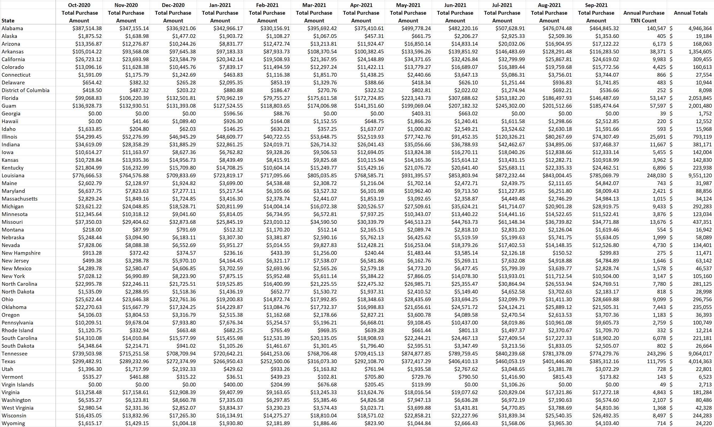

Table 2: MS Recipient SNAP Benefit Spending by US State (Total Transaction Counts)
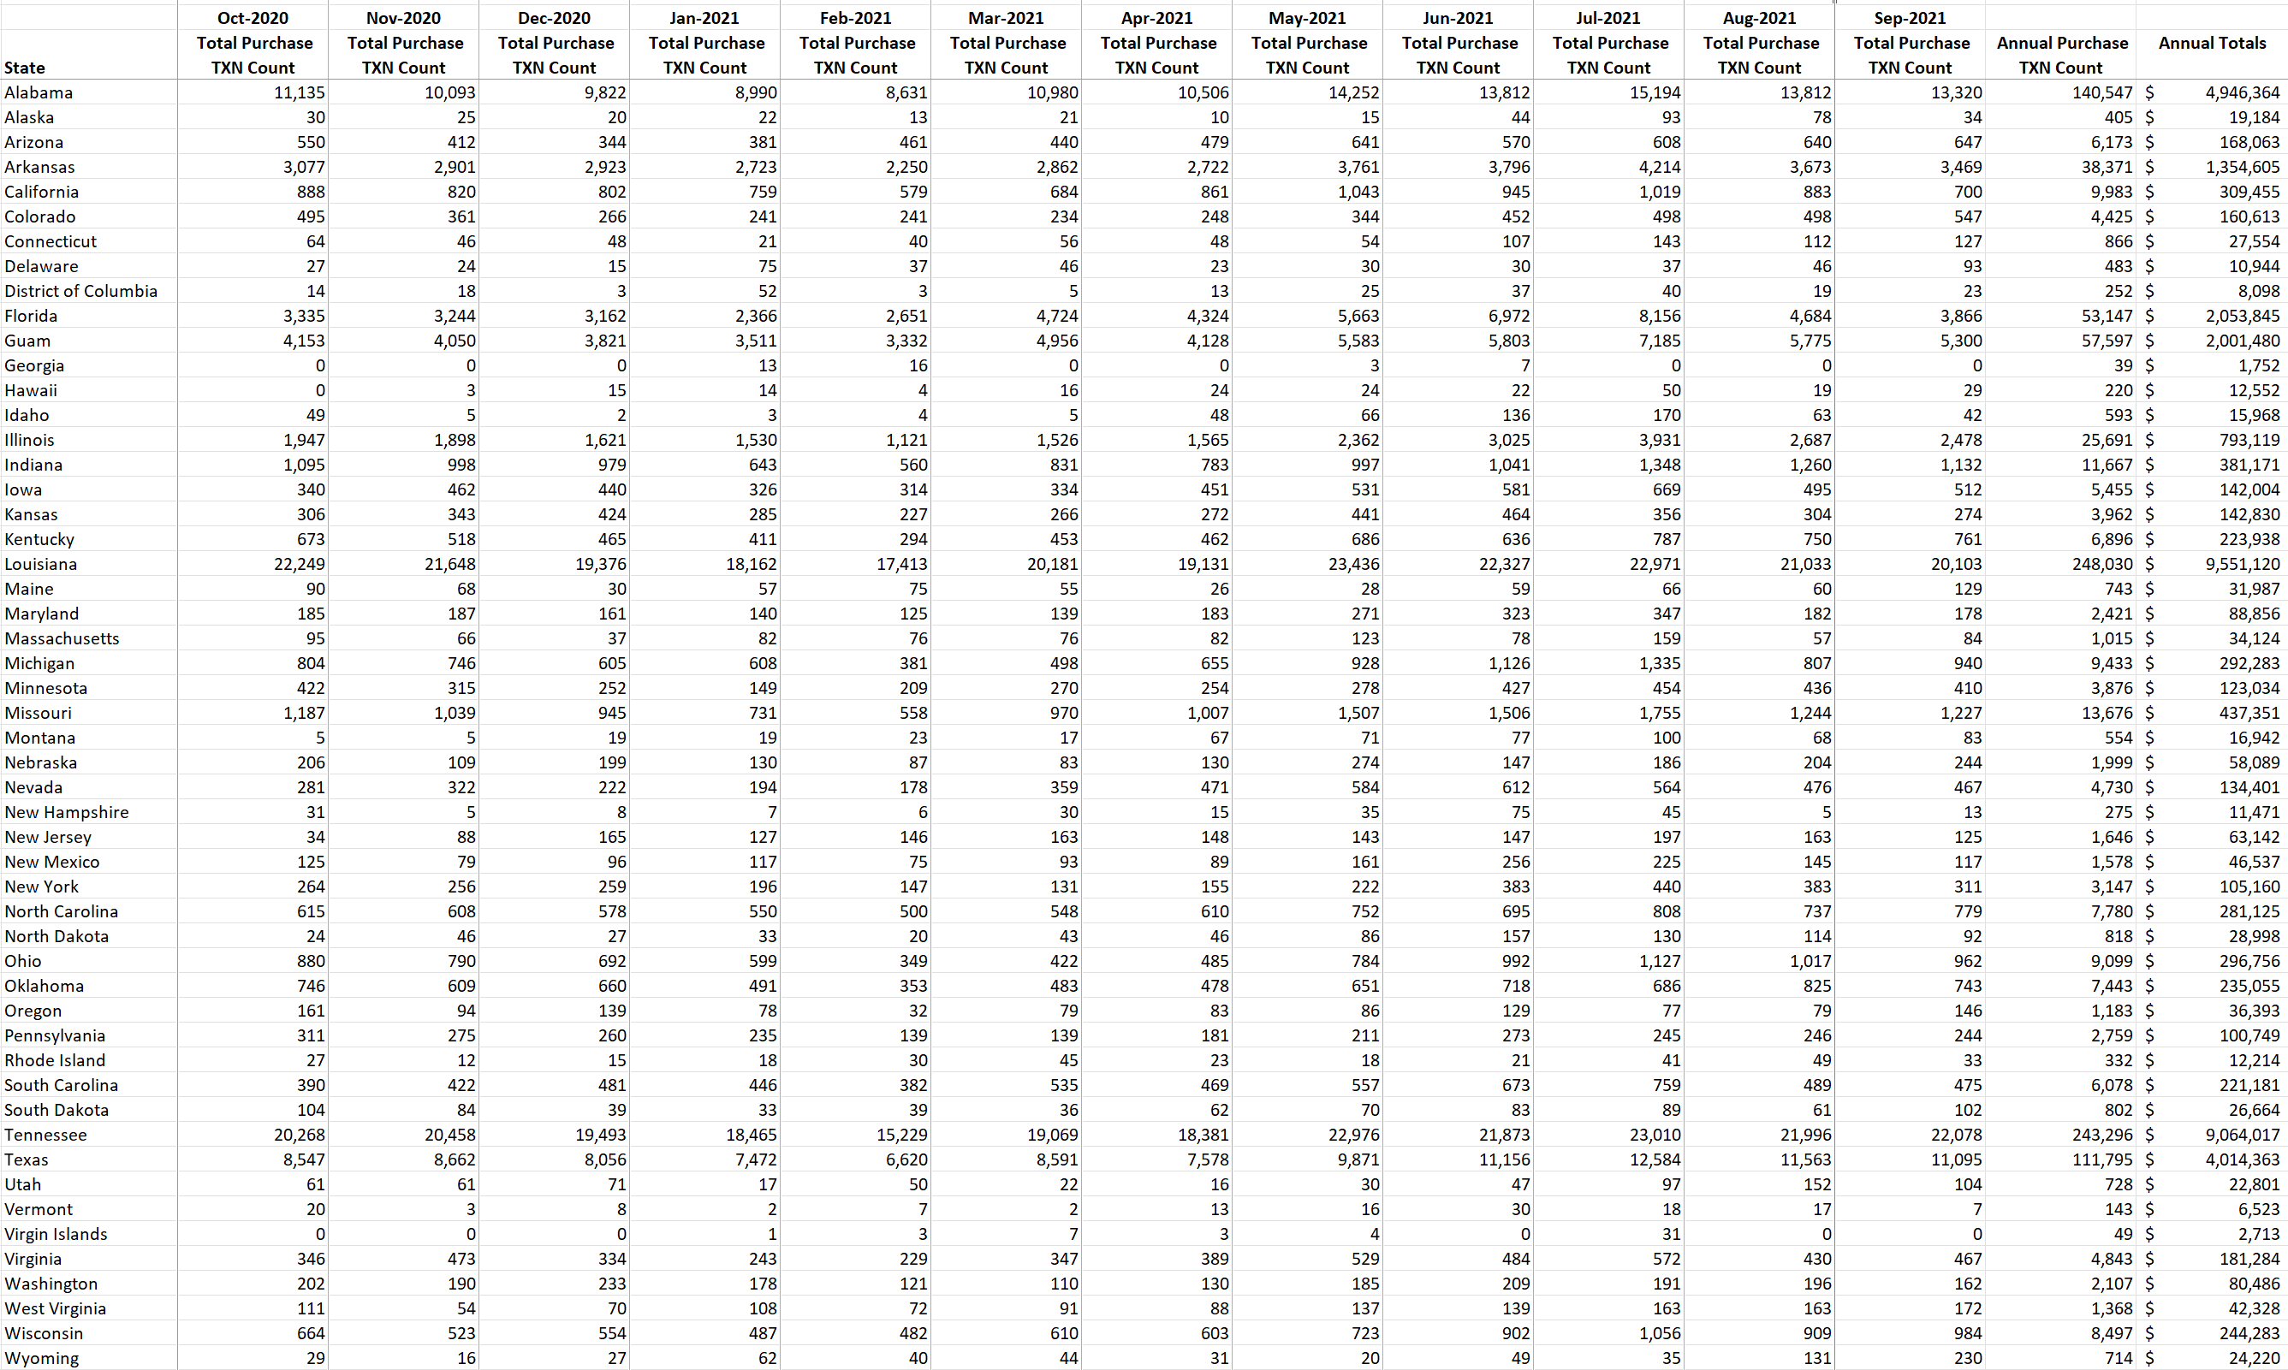
Table 3A: MS Recipient SNAP Benefit Spending by Mississippi County (Purchase Amounts, Counties Starting With A-L)
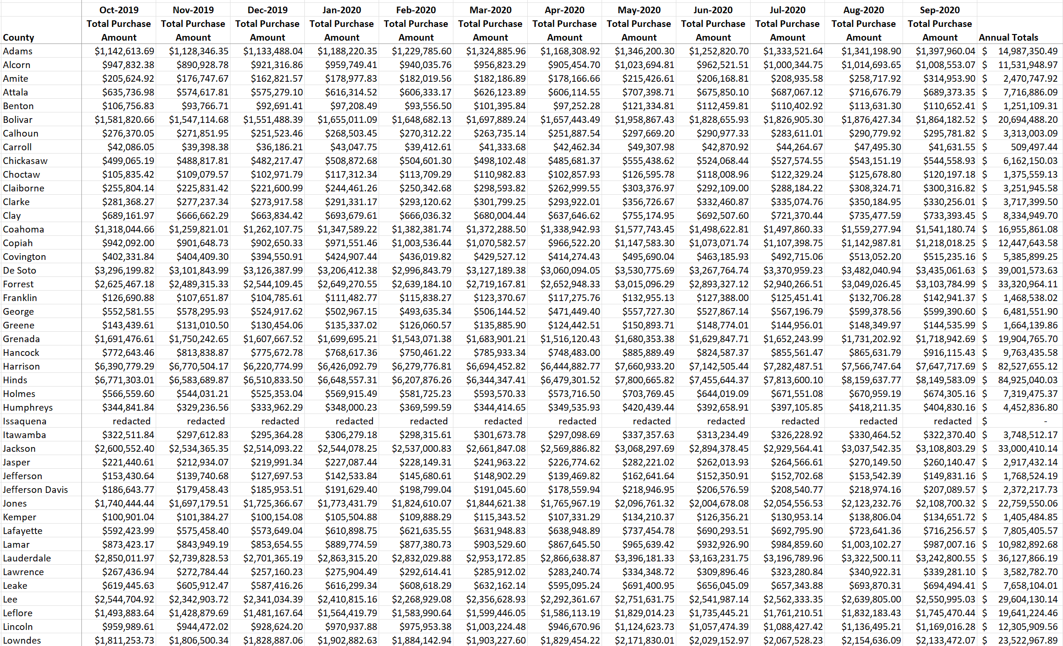
Table 3B: MS Recipient SNAP Benefit Spending by Mississippi County (Purchase Amounts, Counties Starting With M-Y)
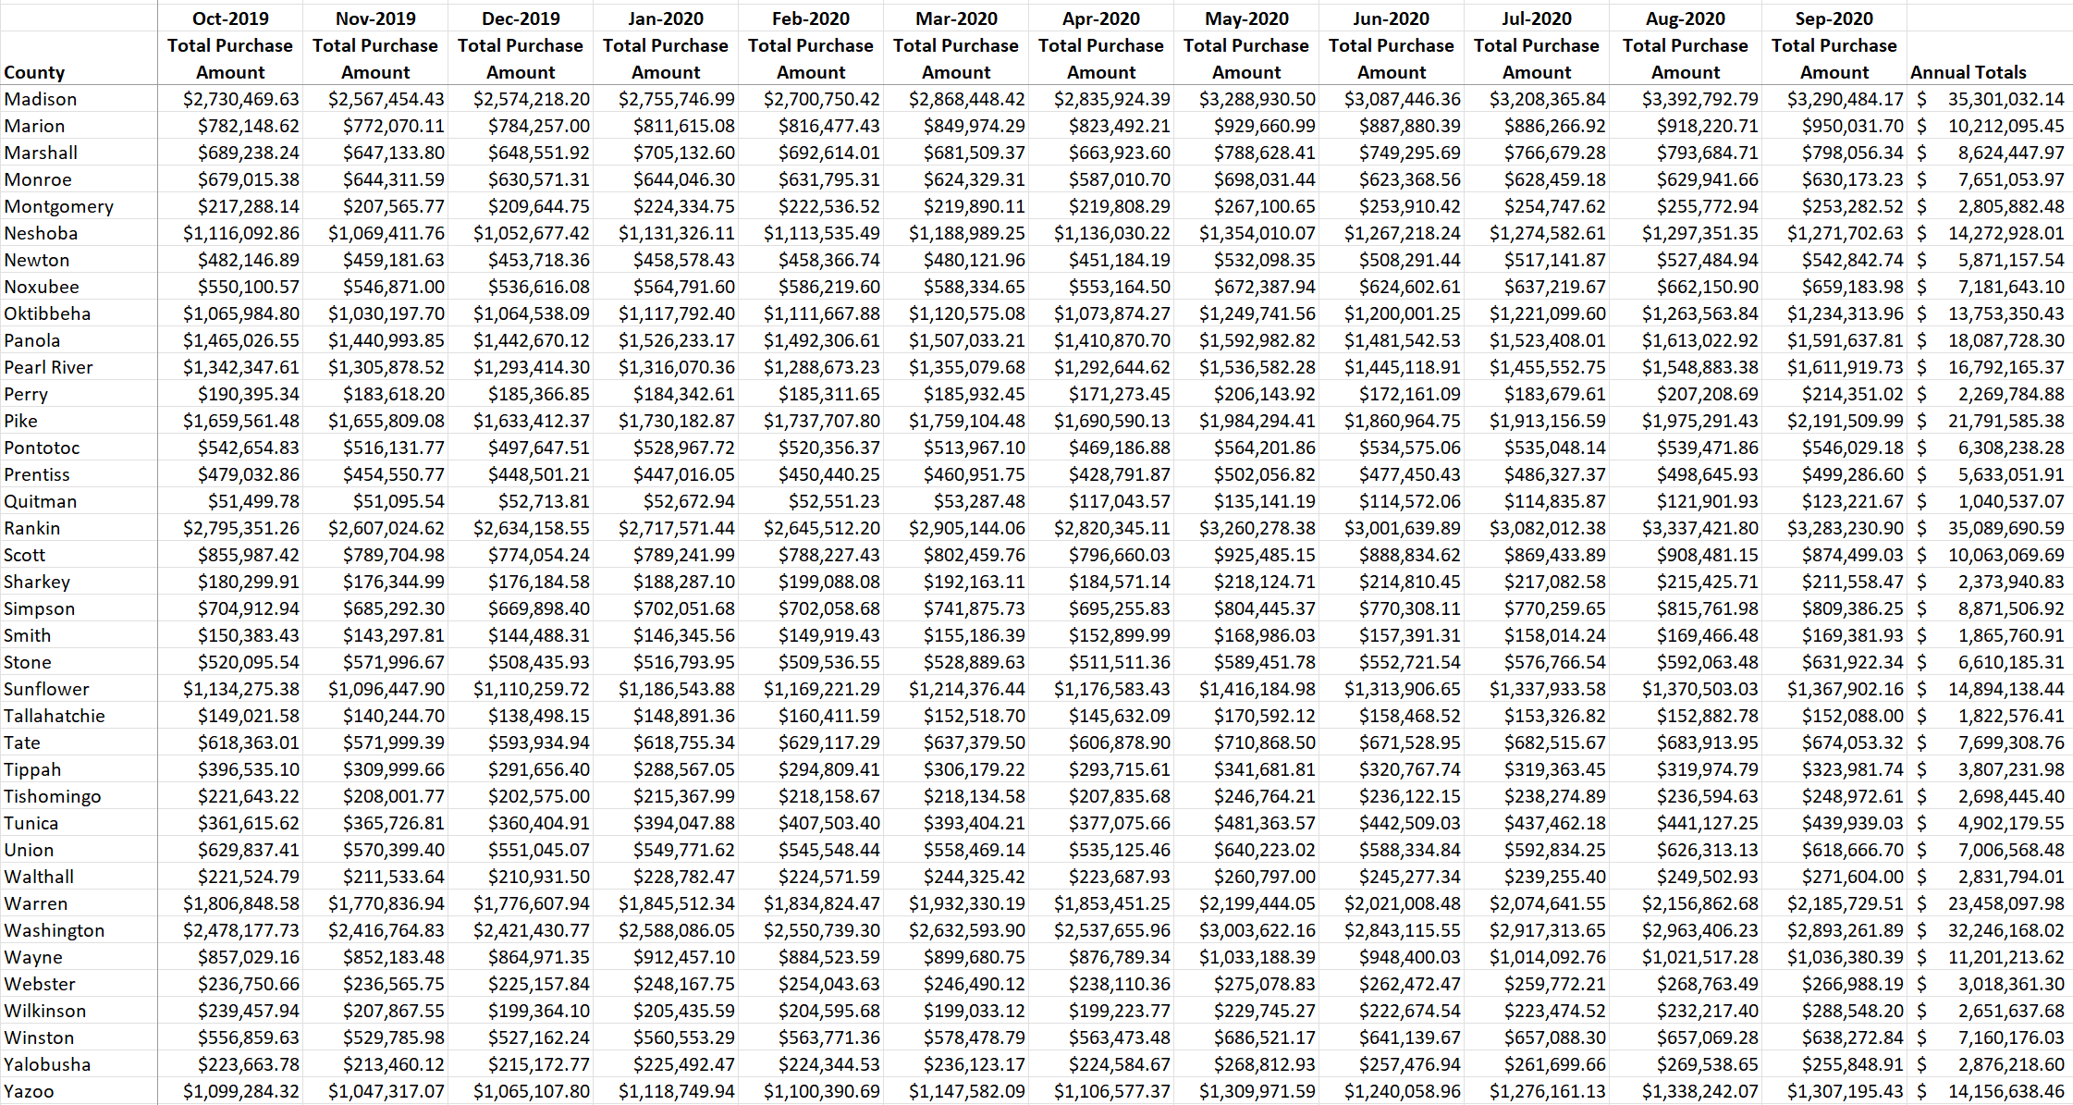
Table 4A: MS Recipient SNAP Benefit Spending by Mississippi County (Total Transaction Counts, Counties Starting with A-L)
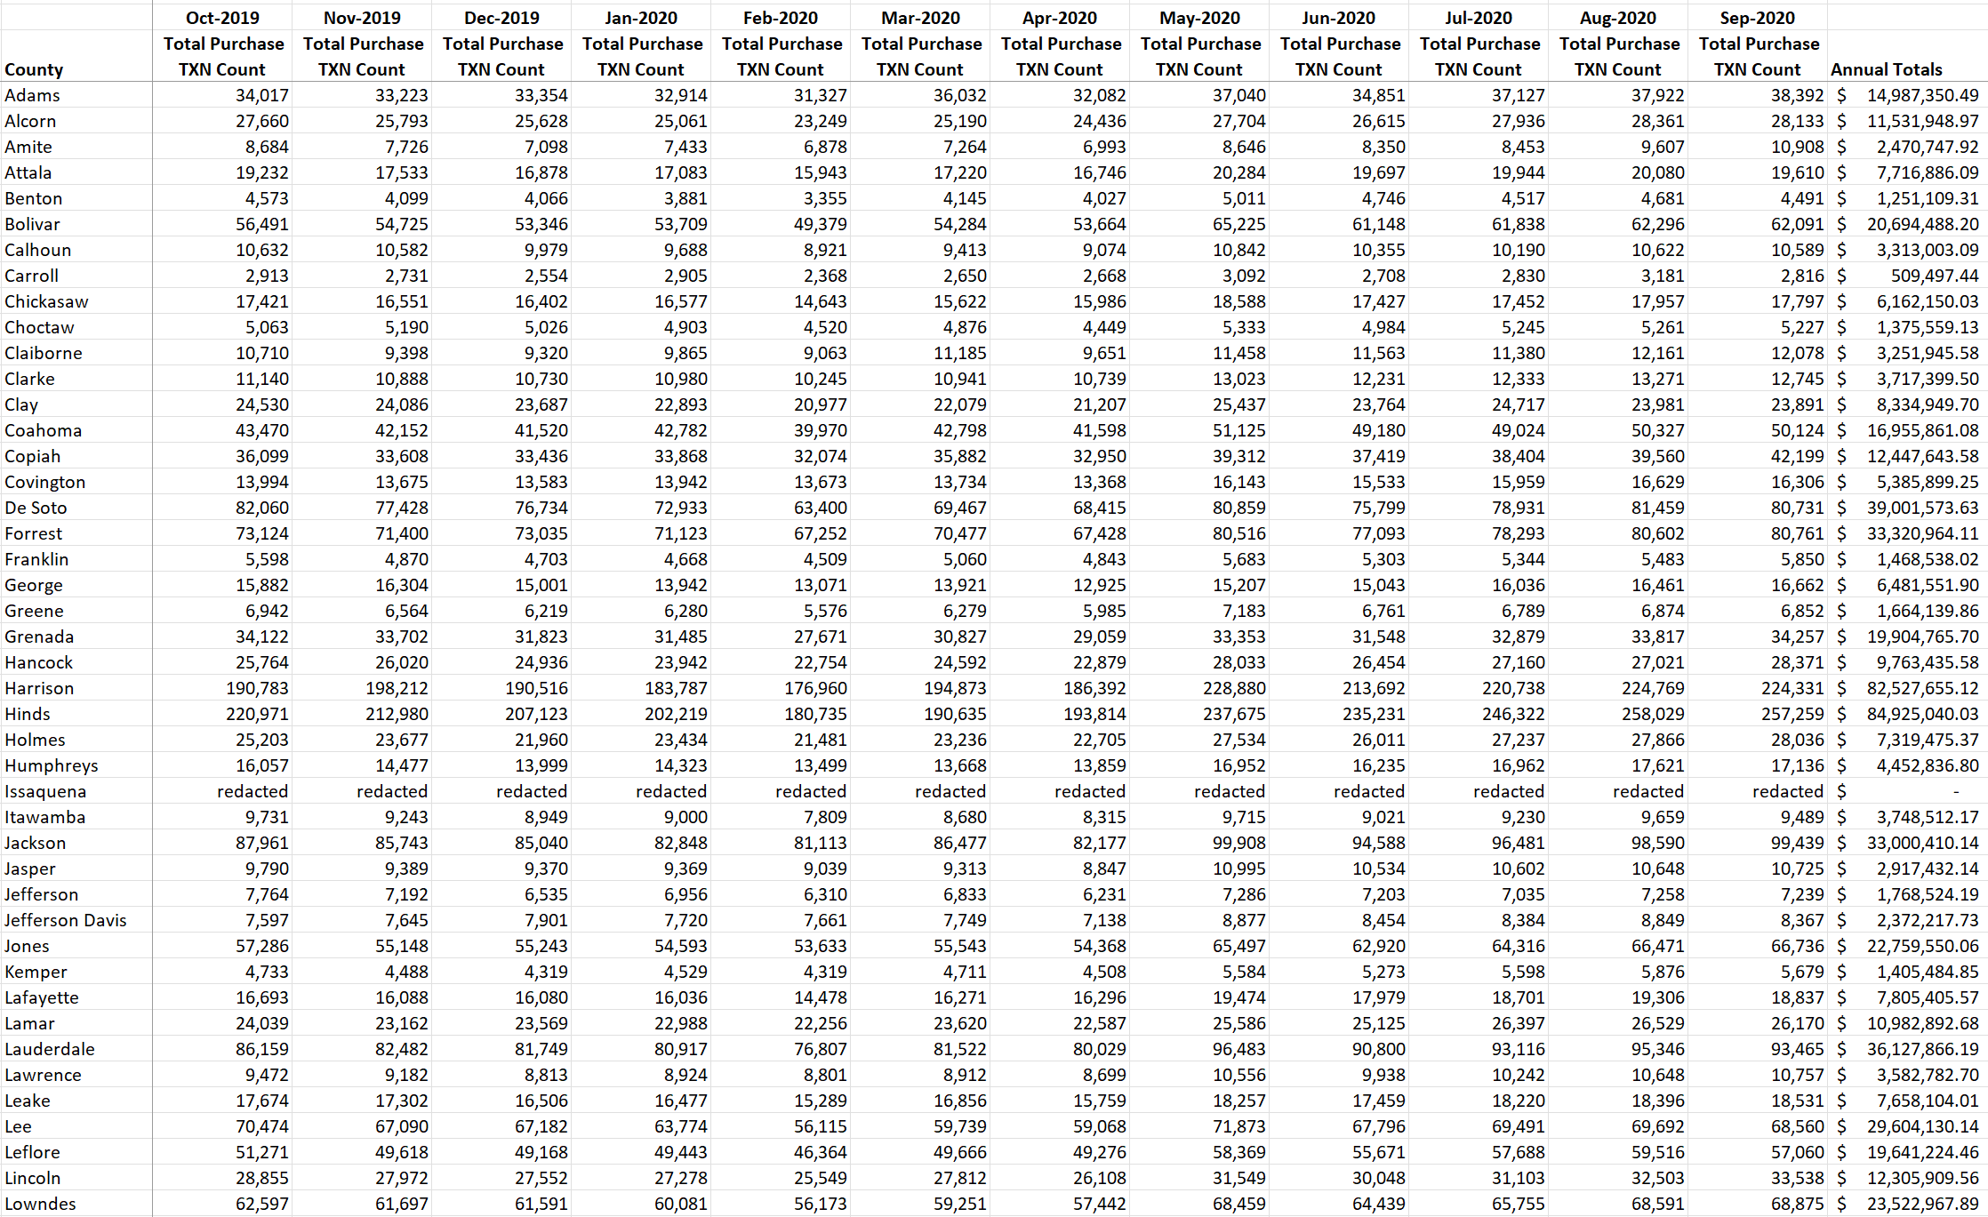
Table 4B: MS Recipient SNAP Benefit Spending by Mississippi County (Total Transaction Counts, Counties Starting with M-Y)
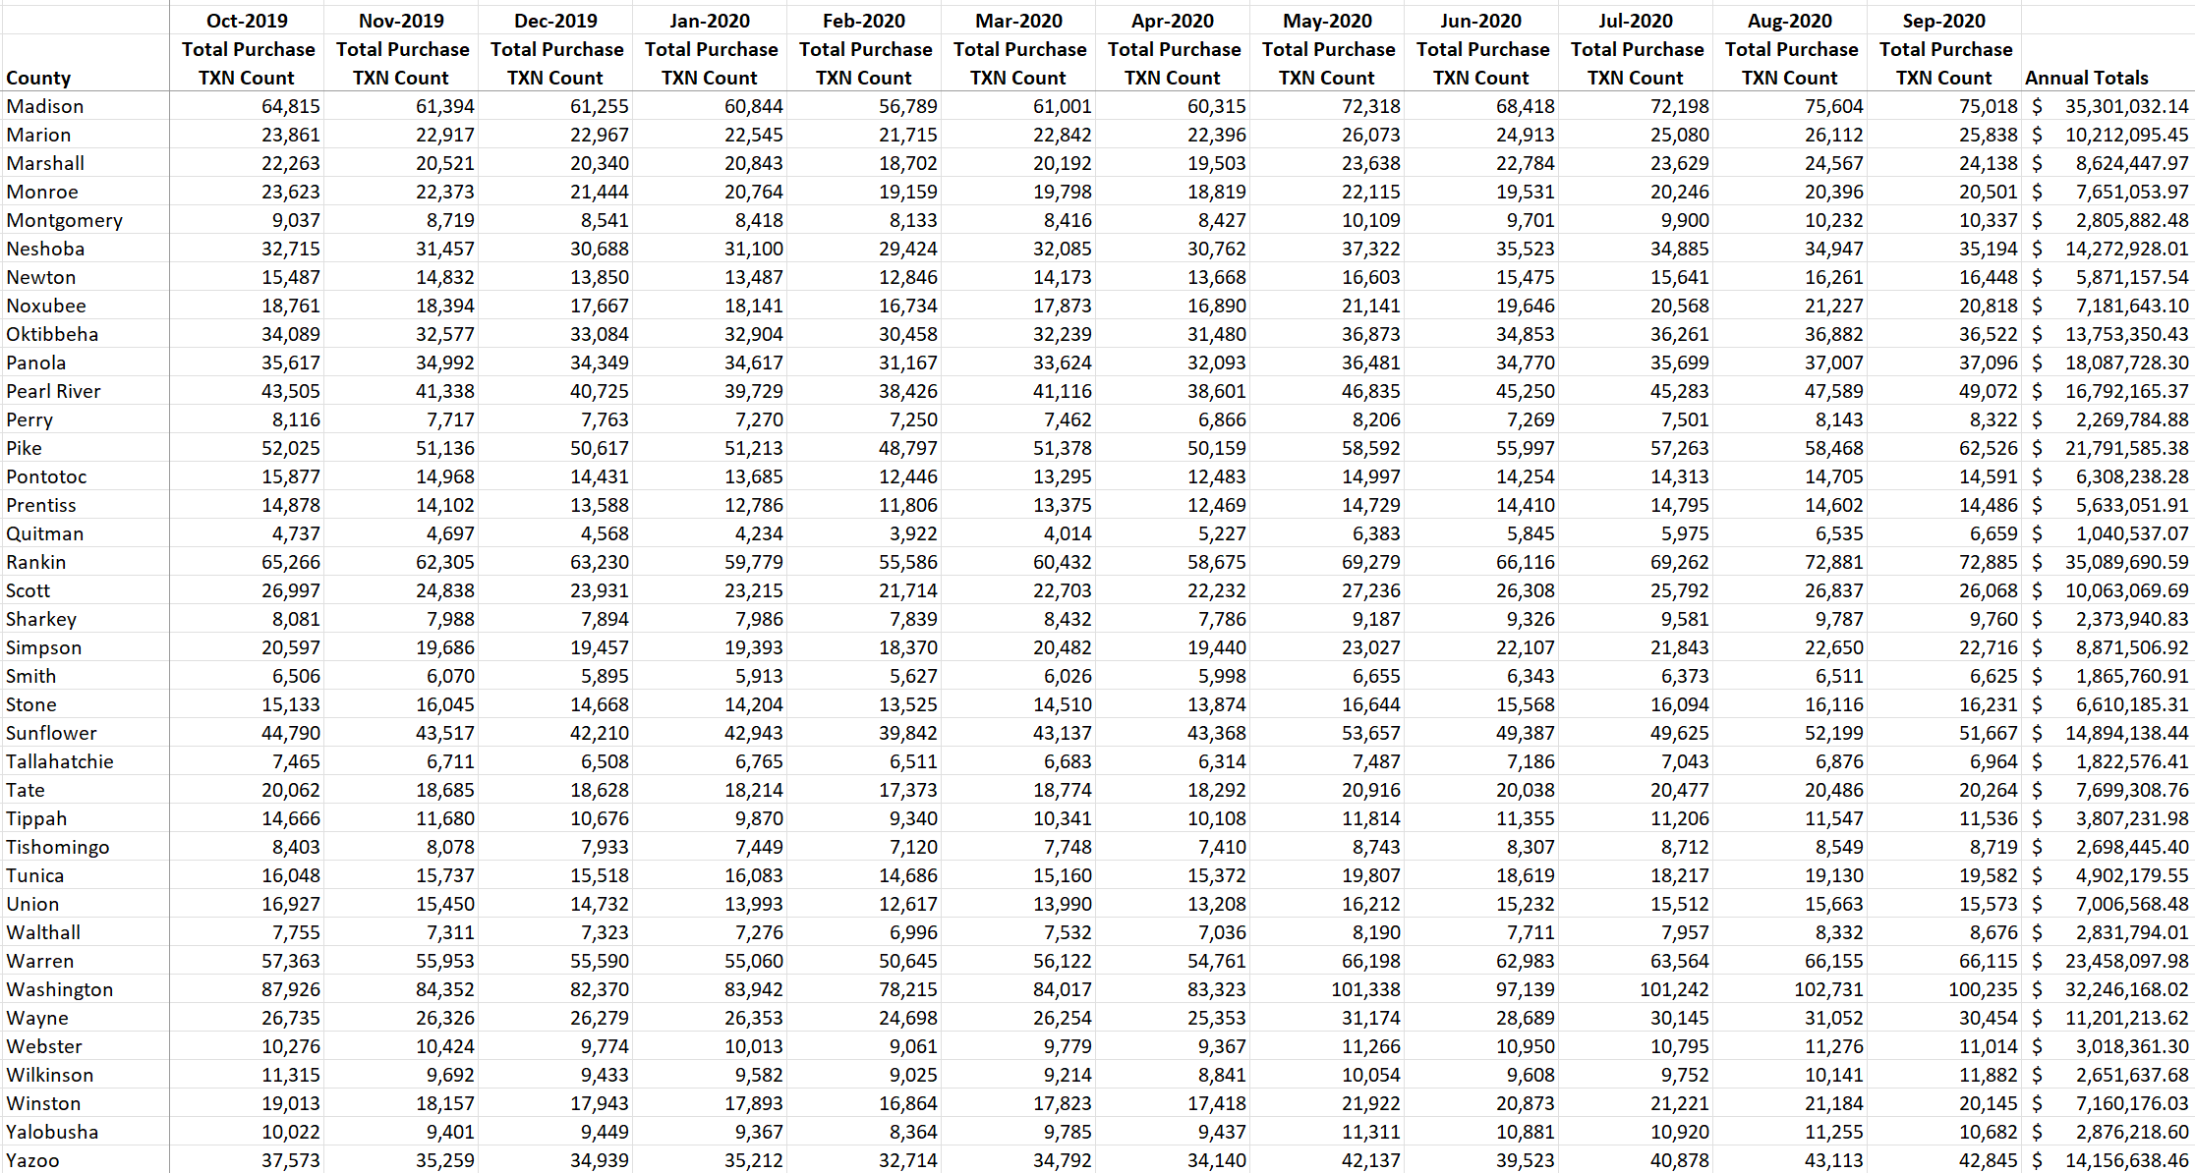
Figure 1: Annual SNAP Spending in Mississippi by County
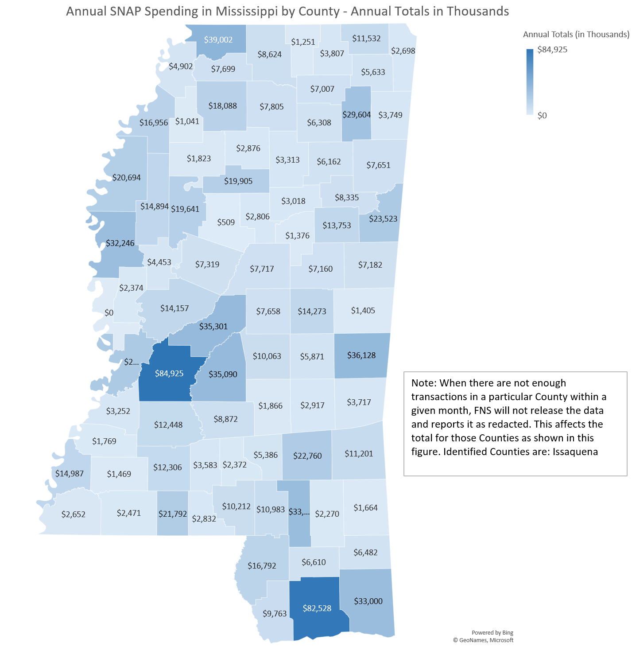

Appendix B: House Bill 1090 – Section 21: Public Reporting

Report Design
This annual report regarding the characteristics of the recipients of Medicaid, SNAP, and TANF benefits is divided into the following subsections.
- The length of enrollment, disaggregated by program and eligibility group
- The share of recipients concurrently enrolled in one or more additional means-tested programs, disaggregated by program and eligibility group and the number of means-tested programs recipients are concurrently enrolled in, disaggregated by program and eligibility group
- The demographics and characteristics of recipients, disaggregated by program and eligibility group
- The dollar amount spent on advertising and marketing for TANF, SNAP, Medicaid, and other means-tested programs, including both state and federal funds, disaggregated by program.
Information gathered for this report includes historical information for Section 6.1.1, while the remaining subsections of the report, only active cases and persons were used to tabulate totals for presentation. This report was created with data from both agencies that reflects a specific point in time: May 27, 2022.

Average Length of Enrollment
The average length of enrollment for each of the programs and eligibility groups listed below was calculated based on the average length of time, in months, using recipients in continuous active status coverage. The data used for this section was gathered from MDHS with a back date or starting date of January 1, 2010 while all available DOM data, gathered from the State Medicaid Management Information System (MMIS), was used.
Table 1: Average Length of Enrollment
Program | Recent Length of Enrollment
SNAP | 43.4 Months
TANF | 13.9 Months
Medicaid Eligibility Groups
Children | 59 Months
Aged | 72 Months
Disabled & Blind | 140 Months
Adults | 36 Months
CHIP | 30 Months
Family Planning Waiver | 19 Months

Recipients Enrolled in One or More Programs
Recipients that are concurrently enrolled in one or more means-tested programs and disaggregated by program as well as the share of recipients in each of the programs are listed in Tables 2A and 2B below.
Note: (1) Population in Table 2B is non-duplicative. All recipients are counted once and placed in their appropriate categories based on the combination of programs in which they are currently active (May 27, 2022).
(2) In this case, breaking the data down by eligibility group within Medicaid/CHIP will have no bearing on the numbers presented. Recipients can only be in one eligibility group at a time in each of the programs.
Table 2A: Recipients Enrolled in Each Program
Program | # of Recipients
SNAP | 397,475
TANF | 4,796
Medicaid/CHIP | 851,503
Table 2B: Recipients Enrolled in One or More Programs
Program | # of Recipients Receiving Benefits | %/Share of Recipients Receiving Benefits
One Program
SNAP Only | 112,642 | 11.67%
TANF Only | 54 | 0.01%
Medicaid/CHIP Only | 567,158 | 58.77%
Subtotal (One Program) | 679,854 | 70.45%
Two Programs
SNAP & TANF | 800 | 0.08%
SNAP & Medicaid/CHIP | 280,403 | 29.06%
TANF & Medicaid/CHIP | 312 | 0.03%
Subtotal (Two Programs) | 281,515 | 29.17%
Three Programs
SNAP, TANF & Medicaid/CHIP | 3,630 | 0.38%
Subtotal (Three Programs) | 3,630 | 0.38%
Grand Total | 964,999 | 100.00%

Demographics and Characteristics of Recipients
The demographics and characteristics of recipients are broken down by Program and Eligibility Group in the following tables:
- Table 3: Recipient Gender
- Table 4: Recipient Age
- Table 5: MDHS Recipient Ethnicity
- Table 6: DOM Recipient Ethnicity
Note: These counts include all household members receiving benefits and are independent by program and eligibility group and will result in recipients being counted more than once as they may show up in both MDHS and DOM data for each of the programs in which they are active.
Table 3: Recipient Gender
Program | Male |  | Female
 | Count | Percentage | Count | Percentage
SNAP | 162,456 | 40.87% | 235,019 | 59.13%
TANF | 1,754 | 36.57% | 3,042 | 63.43%
Medicaid Eligibility Groups
Children | 212,321 | 49.87% | 213,450 | 50.13%
Aged | 27,174 | 35.06% | 50,328 | 64.94%
Disabled & Blind | 83,110 | 48.68% | 87,607 | 51.32%
Adults | 7,312 | 6.65% | 102,669 | 93.35%
CHIP | 21,065 | 50.71% | 20,474 | 49.29%
Family Planning Waiver | 3,314 | 12.75% | 22,679 | 87.25%
Totals | 518,506 | 41.36% | 735,268 | 58.64%

Table 4: Recipient Age
Program | 0-18 | 19-34 | 35-54 | 55 +
SNAP | 171,209 | 68,363 | 79,121 | 78,782
TANF | 3,153 | 674 | 578 | 391
Medicaid Eligibility Groups
Children | 384,496 | 41,274 | 0 | 0
Aged | 0 | 0 | 0 | 77,503
Disabled & Blind | 22,816 | 20,880 | 49,092 | 77,929
Adults | 173 | 70,099 | 38,338 | 1,371
CHIP | 40,151 | 1,387 | 0 | 0
Family Planning Waiver | 74 | 19,830 | 6,090 | 0
Totals | 622,072 | 222,507 | 173,219 | 235,976

Note: MDHS and DOM use differing methods to classify the ethnicity of their clients, thus they are represented in two separate tables, Table 5 and Table 6.
Table 5: MDHS Recipient Ethnicity
Program | African American | American Indian | Asian | Hawaiian/Pacific Islander | White | Other
SNAP | 270,154 | 2,029 | 960 | 100 | 111,840 | 12,392
TANF | 3,693 | 16 | 3 | 10 | 931 | 143
Totals | 273,847 | 2,045 | 963 | 110 | 112,771 | 12,535

Table 6: DOM Recipient Ethnicity
Ethnicity | Children | Aged | Disabled & Blind | Adults | CHIP | Family Planning Waiver
Asian | 1,630 | 388 | 384 | 203 | 313 | 74
Asian-Indian | 322 | 38 | 13 | 51 | 69 | 9
Black/African American | 226,428 | 37,592 | 91,706 | 64,632 | 18,688 | 16,639
Caucasian | 132,333 | 30,537 | 54,832 | 41,219 | 17,126 | 8,343
Chinese | 202 | 19 | 22 | 26 | 65 | 7
Filipino | 167 | 28 | 8 | 66 | 13 | 10
Guamanian or Chamorror | 145 | 1 | 6 | 17 | 1 | 2
Hispanic | 9,800 | 296 | 673 | 600 | 908 | 229
Hispanic Refugee | 0 | 0 | 0 | 0 | 0 | 0
Indo-Chinese Refugee | 0 | 0 | 0 | 0 | 0 | 0
Japanese | 23 | 3 | 1 | 8 | 1 | 2
Korean | 52 | 10 | 4 | 16 | 11 | 3
Native American/Alaskan Native | 3,479 | 146 | 556 | 873 | 238 | 109
Native Hawaiian/Pacific Island | 117 | 6 | 10 | 14 | 13 | 5
Other | 48,791 | 4,587 | 3,172 | 1,827 | 3,794 | 454
Samoan | 17 | 0 | 0 | 2 | 5 | 4
Unspecified Race/Unknown | 1,773 | 3,766 | 19,299 | 329 | 208 | 86
Vietnamese | 492 | 85 | 31 | 98 | 85 | 18
Vietnamese Refugee | 0 | 0 | 0 | 0 | 0 | 0
Totals | 425,771 | 77,502 | 170,717 | 109,981 | 41,538 | 25,994

Amount Spent on Advertising Means-Tested Programs
The dollar amount spent in the last fiscal year on advertising and marketing Mississippi’s means-tested programs follow in Table 7. No state funds were spent on advertising or marketing means-tested programs.
Table 7: Amount Spent on Advertising Means-Tested Programs
Program | Amount Spent
MDHS – Economic Assistance Eligibility | $0
DOM - Medicaid | $0

